**DAY 3**

1:Write a program to create student class with data members rollno, marks1,mark2,mark3.

Accept data (acceptInfo()) and display using display member function.

Also display total,percentage and grade.

MAIN

**package** Assignment_3_1;

**import** java.util.Scanner;

**public** **MAIN** {

**public** **static** **void** main(String[] args) {

**int** roll_no;

**double** mark1,mark2,mark3;

Scanner sc=**new** Scanner(System.***in***);

Q_1_1 obj=**new** Q_1_1();

System.***out***.println("Enter Student Details:");

System.***out***.println("Enter Roll No.-");

roll_no=sc.nextInt();

System.***out***.println("mark1-");

mark1=sc.nextInt();

System.***out***.println("mark2-");

mark2=sc.nextInt();

System.***out***.println("mark3-");

mark3=sc.nextInt();

obj.AcceptDetails(roll_no, mark1, mark2, mark3);

obj.display();

}

}

STUDENT CLASS

**package** Assignment_3_1;

**import** java.math.*;

**public** **class** STUDENT {

**private** **int** roll_no;

**private** **double** mark1,mark2,mark3,total,percentage;

**public** **void** AcceptDetails(**int** roll_no,**double** mark1,**double** mark2,**double** mark3)

{

**this**.roll_no=roll_no;

**this**.mark1=mark1;

**this**.mark2=mark2;

**this**.mark3=mark3;

}

**public** **void** display()

{

System.***out***.println("Roll No.-"+roll_no);

System.***out***.println("Mark1-"+mark1);

System.***out***.println("Mark2-"+mark2);

System.***out***.println("Mark3-"+mark3);

System.***out***.println("Total-"+(mark1+mark2+mark3));

percentage=((mark1+mark2+mark3)/300)*100;

String p=String.*format*("%.2f", percentage);

System.***out***.println("Percentage-"+p);

}

}

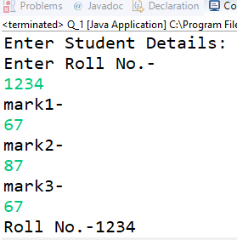

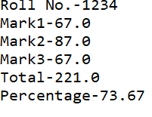

2. Create a class Person with data members as name, age, city. Write getters and setters for all the data members. Also add the display function. Create Default and Parameterized constructors. Create the object of this class in main method and invoke all the methods in that class.

**package** Assignment_3_1;

**public** **class** Main_Person {

**public** **static** **void** main(String [] args)

{

System.***out***.println("---Paramaterized Constructor Invoked---");

Person p=**new** Person("Mayank","Raipur",22);

System.***out***.println("---Display Fucntion Invoked---");

p.display();

System.***out***.println("---Getters Invoked---");

System.***out***.println(p.getName());

System.***out***.println(p.getAge());

System.***out***.println(p.getCity());

System.***out***.println("---Setters Invoked---");

p.setName("Akash");

p.setAge(24);

p.setCity("Pune");

p.display();

}

}

**package** Assignment_3_1;

**public** **class** Person {

**private** String name,city;

**private** **int** age;

Person()

{

age=22;

city="Raipur";

name="Harsh";

}

Person(String name,String city,**int** age)

{

**this**.age=age;

**this**.city=city;

**this**.name=name;

}

**public** **int** getAge() {

**return** age;

}

**public** String getName() {

**return** name;

}

**public** String getCity() {

**return** city;

}

**public** **void** setName(String name)

{

**this**.name=name;

}

**public** **void** setCity(String city)

{

**this**.city=city;

}

**public** **void** setAge(**int** age)

{

**this**.age=age;

}

**public** **void** display()

{

System.***out***.println("Name-"+name);

System.***out***.println("Age-"+age);

System.***out***.println("City-"+city);

}

}

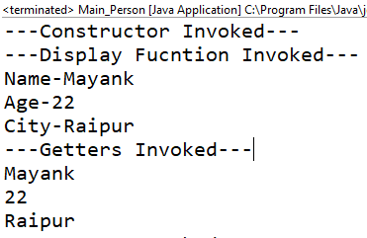

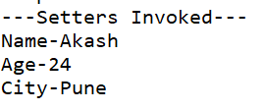

3. Create a class Date with data members as dd, mm, yy. Write getters and setters for all the data members. Also add the display function. Create Default and Parameterized constructors. Create the object of this class in main method and invoke all the methods in that class.

**package** Assignment_3_1;

**public** **class** MAIN_Data {

**public** **static** **void** main(String[] args)

{

System.***out***.println("---Paramaterized Constructor Invoked---");

Date d=**new** Date(10,12,2023);

System.***out***.println("---Display Method Invoked---");

d.display();

System.***out***.println("---Getters Invoked---");

System.***out***.println(d.getDate());

System.***out***.println(d.getMonth());

System.***out***.println(d.getYear());

System.***out***.println("---Setters Invoked---");

d.setDate(23);

d.setMonth(03);

d.setYear(2009);

d.display();

}

}

**package** Assignment_3_1;

**public** **class** Date {

**private** **int** dd,mm,yy;

Date()

{

dd=06;

mm=03;

yy=2001;

}

Date(**int** dd,**int** mm,**int** yy)

{

**this**.dd=dd;

**this**.mm=mm;

**this**.yy=yy;

}

**public** **void** display()

{

System.***out***.println("Date :- "+dd+"/"+mm+"/"+yy);

}

**public** **int** getDate()

{

**return** dd;

}

**public** **int** getMonth()

{

**return** mm;

}

**public** **int** getYear()

{

**return** yy;

}

**public** **void** setDate(**int** dd)

{

**this**.dd=dd;

}

**public** **void** setMonth(**int** mm)

{

**this**.mm=mm;

}

**public** **void** setYear(**int** yy)

{

**this**.yy=yy;

}

}

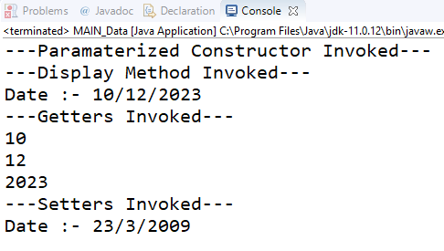

4. Create a class Book with data members as bname,id,author,price. Write getters and setters for all the data members. Also add the display function. Create Default and Parameterized constructors. Create the object of this class in main method and invoke all the methods in that class.

**package** Assignment_3_1;

**public** **class** MAIN_Book {

**public** **static** **void** main(String[] args) {

System.***out***.println("---Paramaterized Constructor Gets Invoked---");

Book b=**new** Book("Theory Of Everything",1001,"Stephen Hawkings",400.00);

System.***out***.println("---Display Method Gets Invoked---");

b.display();

System.***out***.println("---Getter Get Invoked---");

System.***out***.println(b.getBookName());

System.***out***.println(b.getAuthor());

System.***out***.println(b.getId());

System.***out***.println(b.getPrice());

System.***out***.println("---Setters Get Invoked---");

b.setAuhtor("R.D.Sharma");

b.setBookName("Mathematics");

b.setPrice(700.00);

b.setId(1065);

b.display();

}

}

**package** Assignment_3_1;

**public** **class** Book {

**private** String bname,author;

**private** **int** id;

**private** **double** price;

Book()

{

bname="Harry Potter";

id=1001;

author="J.K.Rowling";

price=800.0;

}

Book(String bname,**int** id,String author,**double** price)

{

**this**.author=author;

**this**.bname=bname;

**this**.id=id;

**this**.price=price;

}

**public** **void** display()

{

System.***out***.println("Name:-"+bname);

System.***out***.println("Id:-"+id);

System.***out***.println("Author:-"+author);

System.***out***.println("Price:-"+price);

}

**public** String getBookName()

{

**return** bname;

}

**public** String getAuthor()

{

**return** author;

}

**public** **double** getPrice()

{

**return** price;

}

**public** **int** getId()

{

**return** id;

}

**public** **void** setBookName(String bname)

{

**this**.bname=bname;

}

**public** **void** setAuhtor(String author)

{

**this**.author=author;

}

**public** **void** setId(**int** id)

{

**this**.id=id;

}

**public** **void** setPrice(**double** price)

{

**this**.price=price;

}

}

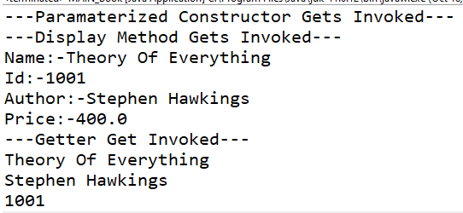

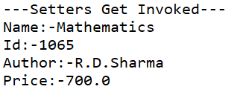

5. Create a class Point with data members as x,y. Create Default and Parameterized constructors. Write getters and setters for all the data members. Also add the display function. Create the object of this class in main method and invoke all the methods in that class.

**package** Assignment_3_1;

**public** **class** MAIN_Point {

**public** **static** **void** main(String[] args) {

System.***out***.println("---Paramaterized Constructor Gets Invoked---");

Point p=**new** Point(2,3);

System.***out***.println("---Display Function Gets Invoked---");

p.display();

System.***out***.println("---Getters Get Invoked---");

System.***out***.println("x = "+p.getXCoordinate());

System.***out***.println("y = "+p.getYCoordinate());

System.***out***.println("---Setters Get Invoked---");

p.setXCoordiante(4);

p.setYCoordinate(5);

p.display();

}

}

**package** Assignment_3_1;

**public** **class** Point {

**private** **int** x;

**private** **int** y;

//Default Constructor

Point()

{

x=5;

y=10;

}

//Paramaterized Constructor

Point(**int** x,**int** y)

{

**this**.x=x;

**this**.y=y;

}

//Display Fucntion

**public** **void** display()

{

System.***out***.println("Point = ("+x+","+y+")");

}

//Getters

**public** **int** getXCoordinate()

{

**return** x;

}

**public** **int** getYCoordinate()

{

**return** y;

}

//Setters

**public** **void** setXCoordiante(**int** x)

{

**this**.x=x;

System.***out***.println("x = "+x);

}

**public** **void** setYCoordinate(**int** y)

{

**this**.y=y;

System.***out***.println("y = "+y);

}

}

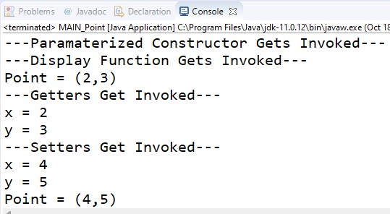

6. Create a class Complex Number with data members real, imaginary. Create Default and Parameterized constructors. Write getters and setters for all the data members. Also add the display function. Create the object of this class in main method and invoke all the methods in that class.

**package** Assignment_3_1;

**public** **class** MAIN_Complex {

**public** **static** **void** main(String[] args)

{

System.***out***.println("---Paramaterized Constructor Gets Invoked---");

Complex c=**new** Complex(10,20);

System.***out***.println("---Display Function Gets Invoked---");

c.display();

System.***out***.println("---Getters Gets Invoked---");

System.***out***.println("Real = "+c.getReal());

System.***out***.println("Imaginary = "+c.getImaginary());

System.***out***.println("---Setters Gets Invoked---");

c.setReal(50);

c.setImaginary(100);

c.display();

}

}

**package** Assignment_3_1;

**public** **class** Complex {

**private** **int** real;

**private** **int** imaginary;

// Default Constructor

Complex()

{

real=5;

imaginary=10;

}

//Paramaterized Constructor

Complex(**int** real,**int** imaginary)

{

**this**.real=real;

**this**.imaginary=imaginary;

}

// Dsiplay Function

**public** **void** display()

{

System.***out***.println("Complex Number, z = "+real+"+"+imaginary+"i");

}

//Getters

**public** **int** getReal()

{

**return** real;

}

**public** **int** getImaginary()

{

**return** imaginary;

}

//Setters

**public** **void** setReal(**int** real)

{

**this**.real=real;

System.***out***.println("Real = "+real);

}

**public** **void** setImaginary(**int** imaginary)

{

**this**.imaginary=imaginary;

System.***out***.println("Imaginary = "+imaginary);

}

}

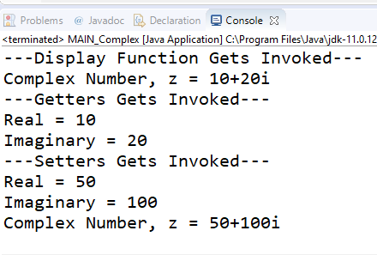

7:create BankAccount aaplication for operations like withdraw ,deposite and moneyTransfer.

Create menu drive program for bank operations..,balance,email...

**package** Assignment_3_1;

**import** java.util.Scanner;

**public** **class** Main_Bank {

**public** **static** **void** main(String[] args) {

Bank b = **null**;

**int** ch = 0;

Scanner sc=**new** Scanner(System.***in***);

System.***out***.println("1.Enter Details 2.Withdraw Money 3.Deposit Money 4.Money Transfer 5.Display Details 6.Exit");

**do** {

System.***out***.print("\nEnter your choice-");

**if**(sc.hasNextInt())

ch=sc.nextInt();

**else**

System.***out***.println("Enter valid choice!!!");

**switch**(ch) {

**case** 1:{

System.***out***.println("\nEnter Account No,Name,Email,Balance");

b=**new** Bank(sc.nextInt(),sc.next(),sc.next());

**break**;

}

**case** 2:{

System.***out***.print("\nEnter the amount you want to withdraw : ");

b.withdraw(sc.nextDouble());

**break**;

}

**case** 3:{

System.***out***.print("\nEnter the amount you want to deposit : ");

b.deposit(sc.nextDouble());

**break**;}

**case** 4:{

System.***out***.print("\nEnter the amount you want to transfer : ");

b.moneyTransfer(sc.nextDouble());

**break**;

}

**case** 5:{

System.***out***.println(b);

**break**;

}

**case** 6:

{

System.***out***.println("---Programm Terminated Successfully---");

**break**;

}

}

}**while**(ch!=6);

}

}

**package** Assignment_3_1;

**public** **class** Bank {

**private** **int** account_no,mobile_no;

**private** String name,email;

**private** **double** balance=10000;

Bank(**int** account_no,String name,String email)

{

System.***out***.println("---Paramatertized Constructor gets invoked---");

**this**.account_no=account_no;

**this**.name=name;

**this**.email=email;

}

**public** String toString()

{

**return** "\nAccount_no - "+account_no+"\nName - "+name+"\nEmail Id - "+email+"\nBalance - "+balance;

}

**public** **void** withdraw(**double** amount)

{

System.***out***.println("---Debited Successfully---");

**this**.balance=balance-amount;

}

**public** **void** deposit(**double** amount)

{

System.***out***.println("---Credited Successfully---");

**this**.balance=balance+amount;

}

**public** **void** moneyTransfer(**double** amount)

{

System.***out***.println("--Money Transferred Successfully---");

**this**.balance=balance-amount;

}

**public** **double** getBalance() {

**return** balance;

}

**public** **void** setMobile_no(**int** mobile_no) {

**this**.mobile_no = mobile_no;

}

}

1.Enter Details

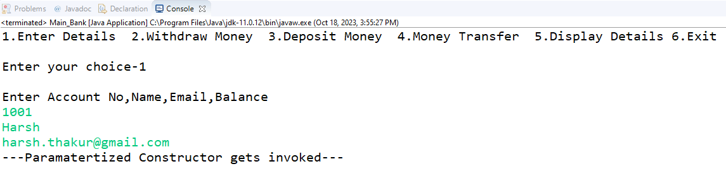

2.Withdraw Money

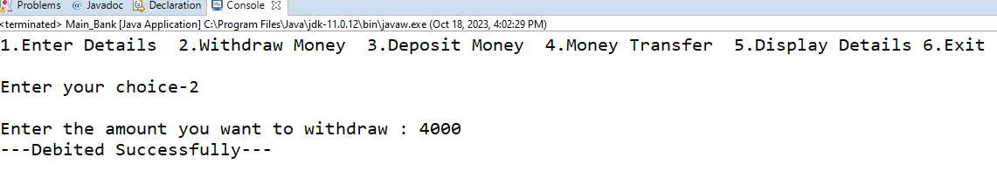

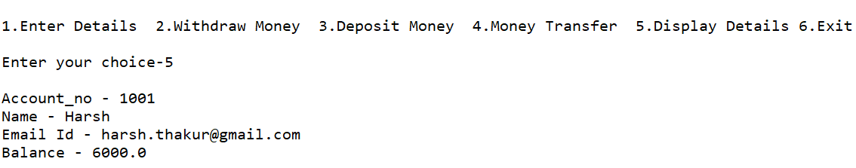

3. Deposit Money

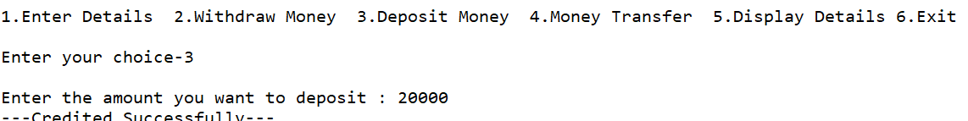

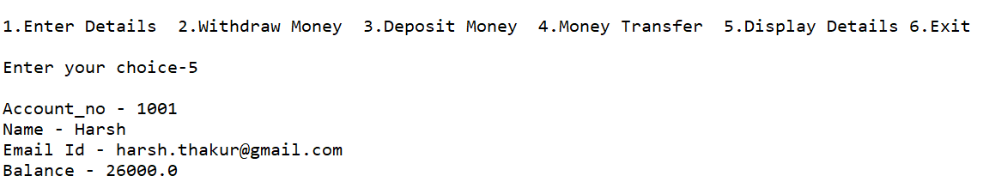

4.Transfer Money

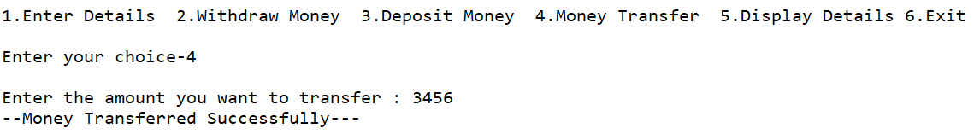

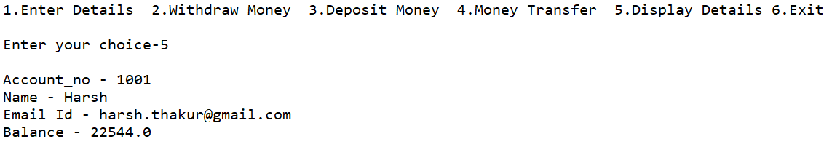

5.Exit

